# **Health-Well Case Study: Analysis**

By: Suraj Honkamble

# **About Health-Well Company:**

Health-well is a digital healthcare platform for inpatient hospitalization, outpatient services, and corporate wellness benefits. Health-well is the award-winning technology platform from Medi Assist that transforms the health insurance industry at the very core. Health-well, with its diverse offerings for various stakeholders of the health benefits industry, makes the process of discovering, accessing, utilizing, and monitoring health benefits seamless, real-time, and virtually paperless. The company was founded in 2000 and based in Bangalore, Karnataka, India.

**Q1. Does the gender of the person matter for the company as a constraint for extending policies?**

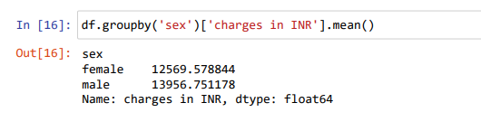

**We observed that both the gender has same number is policy holders and the average Charges Claimed for both gender is almost equal (female:12569.578844, male:13956.751178 Rupees). From the above boxplot we clearly see the distribution of the charges for both male and female and we conclude that the distribution is almost equal for both. Hence The gender of the person should not matter for the company as a constraint for extending policies.**

**Q2. What is the average amount of money the company spent on each policy cover?**

**On an average INR 13270.42 spend on each policy cover**.

**Q3. Could you advise if the company needs to offer separate policies based upon the geographic location of the person?**

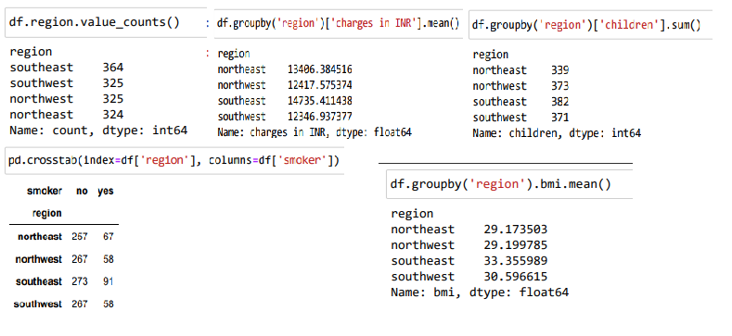

**Average spending in the "southeast" is high and average spending in southwest is low. There are highest dependents on the policy holder in the region of "southeast" and also the more policy holders are "smoker" Hence it is better to provide different policies depends on region.**

**Q4. Does the no. of dependents make a difference in the amount claimed?**

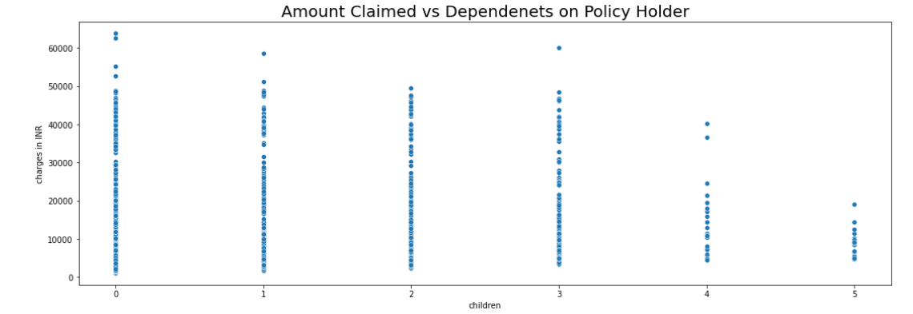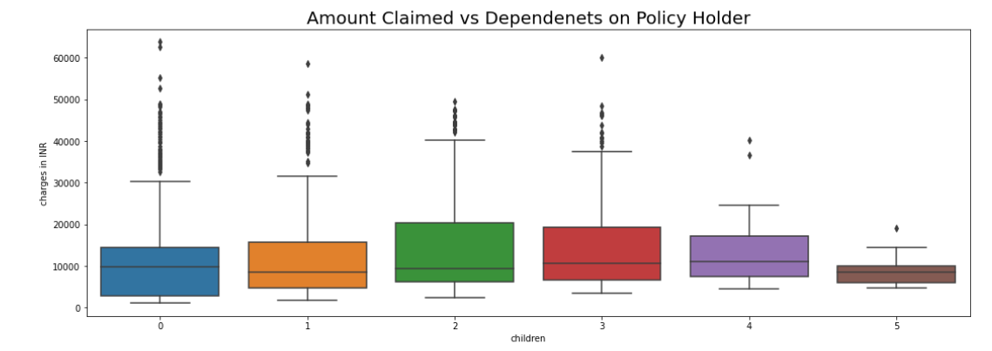

**Maximum policy holders have no dependents and only few policy holders have dependent’s(children’s) 4 or 5. Maximum average amount claimed by policy holders who have children’s 2 or 3. Policy holders having children’s 5 claimed less average amount. Policy holders having children’s 4 claiming 3rd most average amount although they are less in numbers. From above graphs and charts I didn’t think dependents make any difference in claim amount. But The number of dependents may affect the insurance amount claimed in different ways, depending on the type of insurance and the policy terms.**

**Q5. Does a study of a person’s BMI give the company any idea for the insurance claim that it would extend?**

**Yes, a study of a person’s BMI can give the insurance company some idea about the insurance claim that it would extend. BMI can indicate the risk of developing certain health conditions, such as heart diseases, diabetes, and obesity. Insurance companies use BMI to determine the claim amount for the policyholder, as well as the eligibility for the claim. A higher or lower than normal BMI can attract higher claim amount. A normal BMI range is between 18.5 and 24.9, according to the WHO. If the policyholder’s BMI falls outside this range, they may have to undergo additional medical tests or provide proof of their health status before getting insured or claiming the benefits. Some insurance companies may even dismiss claims if the policyholder is found to be overweight or obese at the time of death or diagnosis of a critical illness.**

**Q6. Is it needed for the company to understand whether the person covered is a smoker or a non-smoker?**

### **Yes, it is important for health insurance companies to know whether the person who holds policy is a smoker or a non-smoker. This is because smoking increases the risk of various diseases, such as lung cancer, heart disease, stroke. These conditions can result in higher medical expenses and claims for the insurance company. Therefore, health insurance companies charge higher premiums for smokers than non-smokers to cover the increased risk.**

**Q7. Does age have any barrier on the insurance claimed?**

**Yes. Age can have barrier on the health insurance premium and the claim amount. Usually, older people are more likely to have health issues and require more medical care, which increases the risk for the companies. Therefore, they may have to pay higher premiums.**

**Q8. Can the company extend certain discounts after checking the health status (BMI) in this case?**

**Depends on the insurance company. Some health insurance companies use BMI as a factor to determine the premium amount for individual policy holder. A higher or lower BMI from normal BMI, may indicate a higher risk of health problems and hence they must pay higher premium.**